Rotary Club of Kenmore

Sponsors and Supporter

 | ross evans Garden Centre
 | Amcal Pharmacy, Kenmore Village
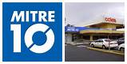 | Mitre 10, Kenmore Village
 | Café Bliss, Kenmore Village
 | Woolworths Kenmore Plaza
 | Coles, Kenmore Village
 | Just Trailers, Rocklea
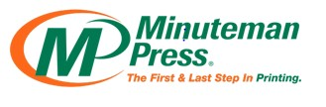 | Minuteman Press, Milton

